

**SOR 1232 - Hypothesis Testing and  
 Statistical Modelling**

**Dr David Suda**

Esther Spiteri (74500L)   
Francesca Chircop (475500L)   
Kelsey Marie Debono (178700L)

B.Sc Computing Science

**Table of Contents**

1. Introduction
   1. Expanation of the variable in the data set
2. Aims and Objectives
3. Descriptive Statistics and Illustrations
4. Parametric and Non-Parametric Tests
5. Modelling
6. Conclusion
7. Bibliography

**1 Introduction**

The dataset chosen is a multivariate set describing seventy-seven commonly available breakfast cereals. The latter was mainly chosen because breakfast is a vital meal since it decreases hunger and cravings throughout the day. Calories is the dependent variable that correlates with all the other variables.  
Data Set retrieved from: <http://lib.stat.cmu.edu/datasets/1993.expo/>

**1.1 Explanation of the variables in the data set**

|  |  |  |  |
| --- | --- | --- | --- |
| ***Covariates Table*** | | | |
| **Variable Name** | **Description** | **Measurement Units** | **Type** |
| Calories | Calories in numbers | Cal | Quantitative |
| Protein | protein | Grams | Quantitative |
| Fat | Fat | Grams | Quantitative |
| sodium | Sodium | Mg | Quantitative |
| Fiber | Dietary fiber | Grams | Quantitative |
| Carbo | Complex carbohydrates | Grams | Quantitative |
| Sugars | Sugars | Grams | Quantitative |
| Potass | Potassium | Mg | Quantitative |

|  |  |
| --- | --- |
| ***Factors Table*** | |
| **Manufacturer** | **Initial** |
| American Home Food Products | A |
| General Mills | G |
| Kelloggs | K |
| Nabisco | N |
| Post | P |
| Quaker Oats | Q |
| Ralston Purina | R |
| **Type** | **Initial** |
| Hot | H |
| Cold | C |

**2 Aims and Objectives**

* To see how the covariates affect the response variable (calories) by observing which covariates contribute most to the calories found in a cereal.
* To observe the relationship between the covariates.
* To come up with the cereal that is the healthiest as well as the cereals that are not very good for a person to consume.

**3 Descriptive Statistics and Illustrations**

As shown in *Figure 1*, the standard deviation of the covariates shows that the majority only are clustered closely around the mean. However, calories, sodium and potassium are less reliable as they have a larger discrepancy from the mean. The high variance of these three covariates also shows that they are widely spread from the mean as well as from each other.

Calories and sodium are negatively skewed. This shows that the data is mostly distributed to the right of the mean. The rest of the covariates are positively skewed and thus their distribution is more to the left of the mean.

Negative kurtosis is a characteristic of sodium, carbohydrates and sugars. This means that their data distribution is relatively flatter as compared to the normal distribution.

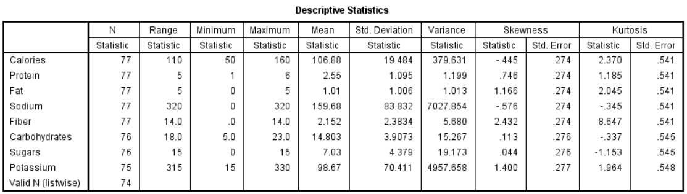

**Figure 1**

The majority of the cereals found in this data set are manufactured by "Kellogs" whilst "American Home Food Products" only manufacture one of the cereals.



**Figure 2**



**Figure 4**

96.1% of the cereals are served cold whereas only 3.9% are served hot.

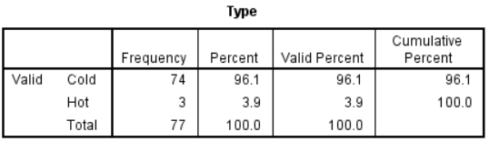

**Figure 3**

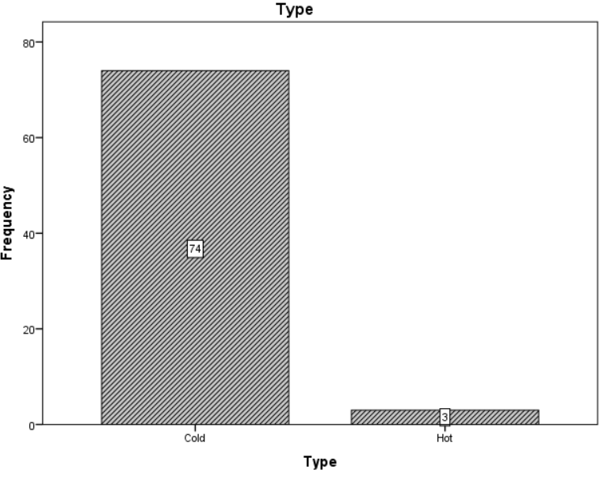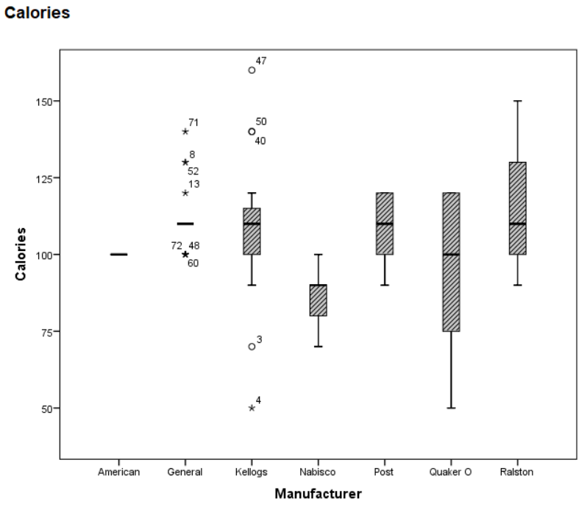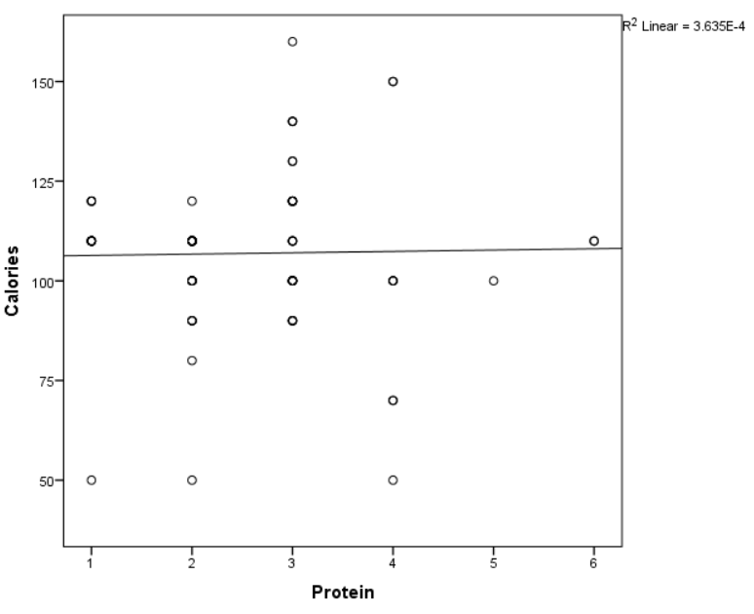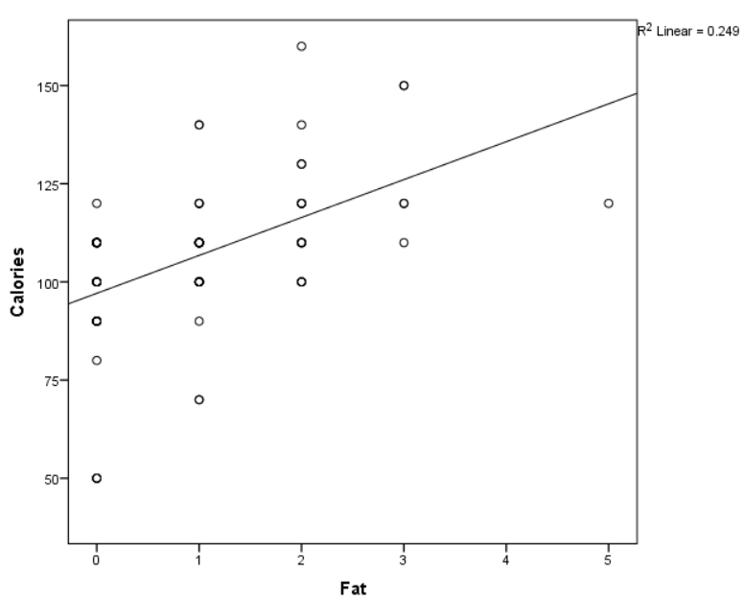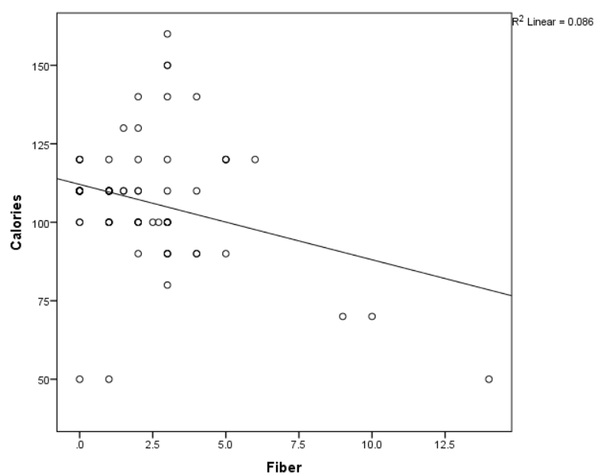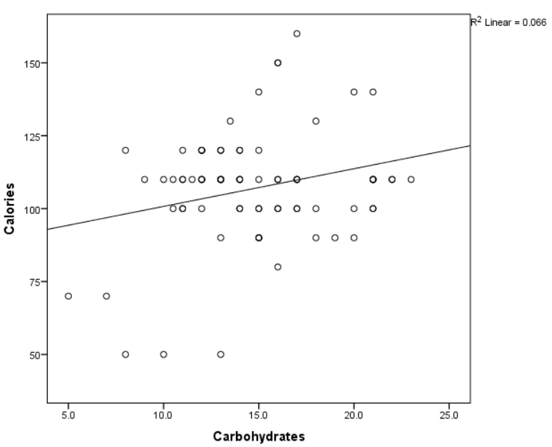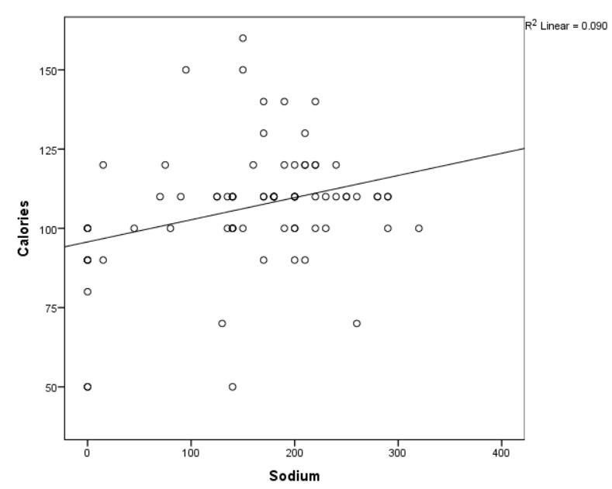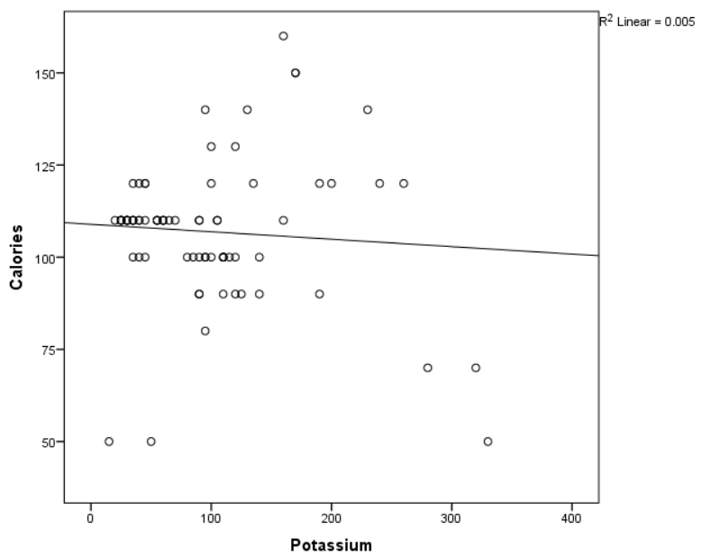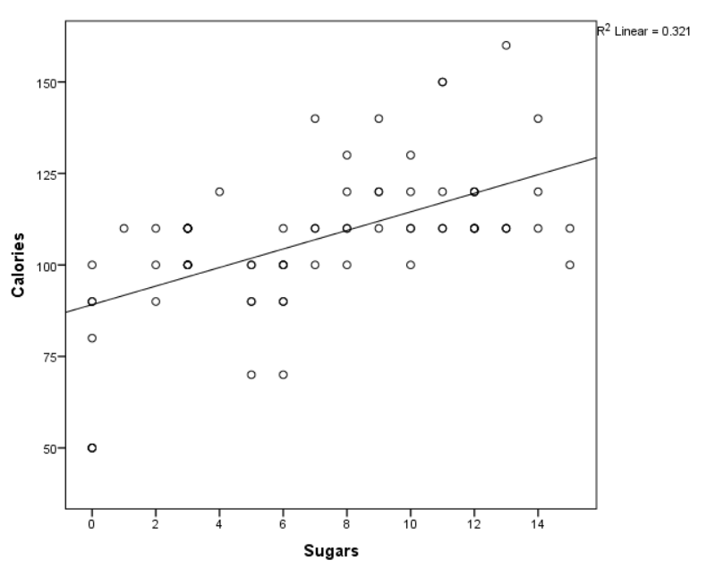

Calorie and protein do not seem to be related as the marked points are quite scattered from the best fit line. The same applies to the calories vs fat, calories vs fiber, calories vs carbohydrates and calories vs potassium plots. However, it can be observed that the calories vs sugars and calories vs sodium plots have a stronger positive linear relationship.

Outliers can be observed throughout all the plots thus implying that none have a perfect linear relationship.



Calories and Fat have a positive linear relationship which is quite weak



A slightly strong positive linear relationship is observed between calories and sugars.



****Less points are found on the best fit line when compared to the previous plot. Therefore, the relationship is weaker.

There seems to be no relationship between potassium and calories. Several outliers can be observed in this.



A strong negative relationship is found between calories and fiber. One can observe that there are few potential outliers.



There is a positive linear relationship, however there isn’t a strong concentration around the line which results in a weak relationship.



There is no relationship between protein and calories.

**4 Parametric and Non-Parametric Tests**

**Hypothesis test for Manufacturer vs Calories**

|  |  |  |  |  |  |  |  |
| --- | --- | --- | --- | --- | --- | --- | --- |
| **Tests of Normality** | | | | | | | |
|  | Manufacturer | Kolmogorov-Smirnova | | | Shapiro-Wilk | | |
|  | Statistic | df | Sig. | Statistic | df | Sig. |
| Calories | General Mills | .370 | 22 | .000 | .765 | 22 | .000 |
| Kellogs | .219 | 23 | .006 | .899 | 23 | .025 |
| Nabisco | .293 | 6 | .117 | .915 | 6 | .473 |
| Post | .209 | 9 | .200* | .889 | 9 | .194 |
| Quaker Oats | .318 | 8 | .017 | .771 | 8 | .014 |
| Ralston Purina | .337 | 8 | .008 | .806 | 8 | .033 |
| *. This is a lower bound of the true significance. | | | | | | | |
| a. Lilliefors Significance Correction | | | | | | | |

Since both the Kolmogorov-Smirnov test and the Shapiro-Wilk test for all but two of the manufacturers, ‘Nabisco’ and ‘Post’, gave out a p-value (sig) of 0 < 0.05, then the hypothesis that ‘Calories’ follows a normal distribution has to be rejected. ‘Calories’ is thus not normally distributed.

The following table presents the results for Levene’s tests. Levene’s test is used to check whether the assumption of equal variances is satisfied. In this case we have the following hypothesis:

* H0: The variances of the manufacturers from which the samples are extracted are equal.
* H1: The variances of the manufacturers from which the samples are extracted are not equal.

|  |  |  |  |
| --- | --- | --- | --- |
| **Test of Homogeneity of Variances** | | | |
| Calories | | | |
| Levene Statistic | df1 | df2 | Sig. |
| 2.576 | 5 | 70 | .034 |

Since the p-value is 0.034, which is less than 0.05, then we reject the null hypothesis. So there is a significant difference in the six manufacturers’ variances.

This implies that the ‘One-Way Anova’ test cannot be carried out as not all manufacturers have a normally distributed calories count and their variances are not equal. Therefore, the non-parametric ‘Kruskal Wallis’ test is used.

**Kruskall Wallis**

|  |  |
| --- | --- |
| **Test Statisticsa,b** | |
|  | Calories |
| Chi-Square | 12.970 |
| df | 5 |
| Asymp. Sig. | .024 |
| a. Kruskal Wallis Test | |
| b. Grouping Variable: Manufacturer | |

Since the p-value is 0.024, which is less than the level of significance, 0.05, H0 is rejected. So there is a significant difference in the median calories found in the cereals produced by the different manufacturers. Post hoc tests can then be applied to test which means are actually significantly different.

**Post-hoc Bonferroni procedure to the Kruskal-Wallis test**

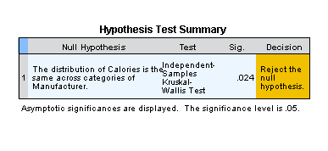

C:\Users\Owner\AppData\Local\Temp\temp8688748008273623605.emf

It can be seen that after the Bonferroni p-value adjustment, only three of the manufacturers are still significantly different from each other. This means that at 0.05 level of significance, “Nabisco”-“Kellogs” and “Nabisco”-“General Mills” pertain to a distinct homogenous group. The rest of the manufacturers are similar to one another since their p-value is greater than 0.05.

**Independent Sample T-Test**

The independent-samples t-test is used to assess whether the means of two independent groups statistically differ from each other. Through this test we would be able to check whether there is a correlation between the amounts of calories in cold cereals against the amounts of calories in hot cereals.

In order to conduct this test, a test of normality was carried out to check whether the dependent variable ‘Calories’ follows a normal distribution for both of the independent groups.

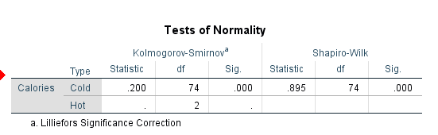

From the test carried out one can observe that the p-value (sig) is 0 < 0.05 therefore Calories is not normally distributed. Thus, since the dependent variable is not normally distributed, we decided to use the Mann-Whitney Test, which is an alternative of the Independent Sample T-Test, that assesses whether the medians of two independent groups statistically differ from each other.

**Mann-Whitney Test**

H0: The median amount of calories is the same for both groups.

H1: The median amount of calories is not the same for both groups.

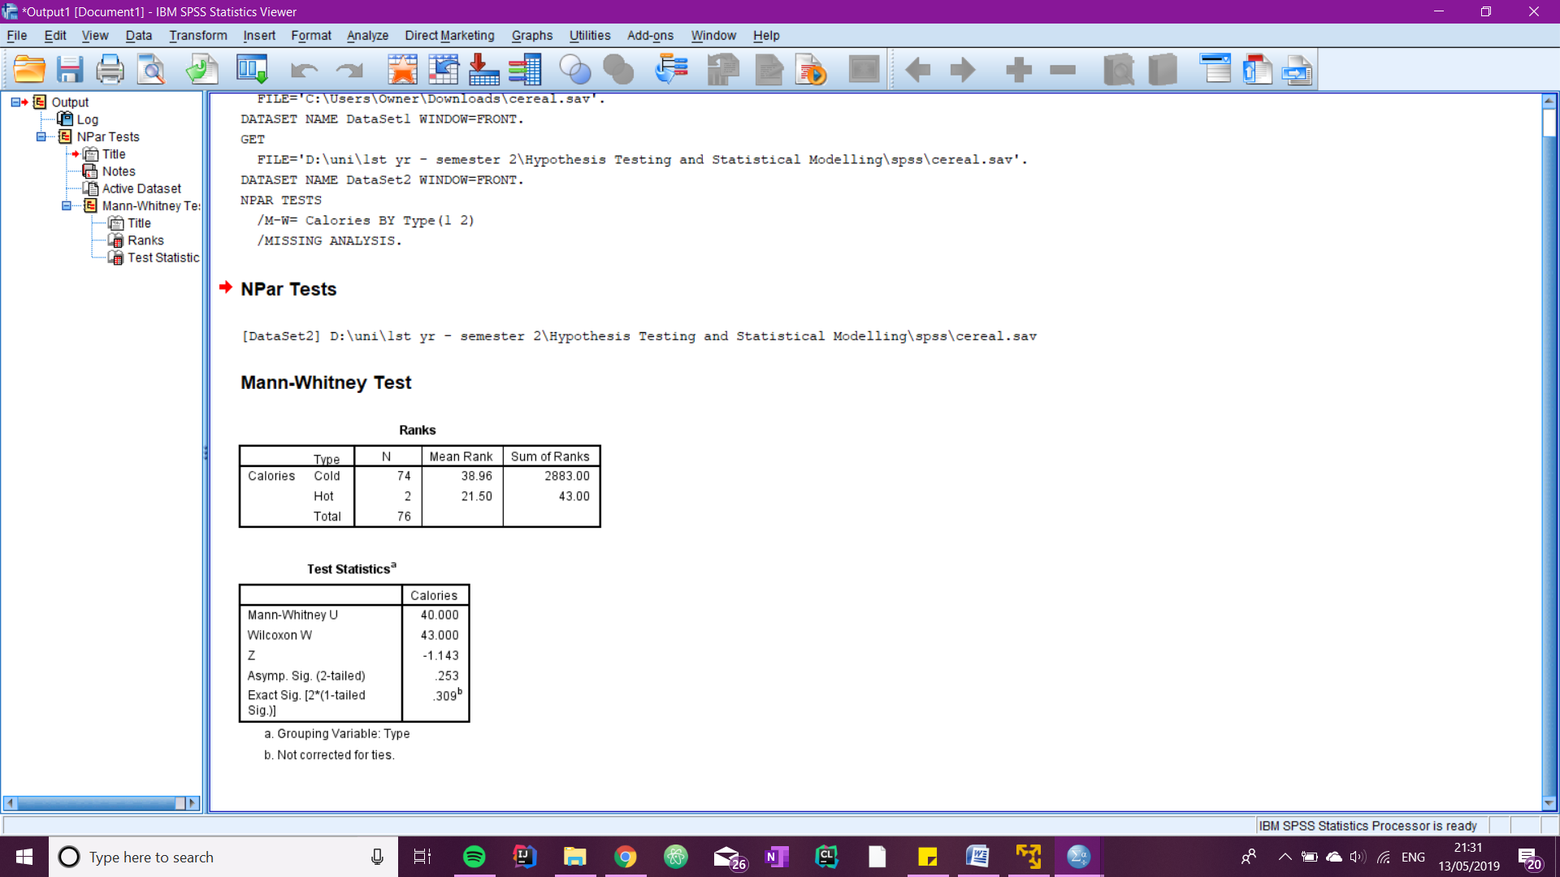

From this test one can notice that the p-value which is 0.253 is greater than the level of significance, therefore H0 cannot be rejected and we can state that the median amount of calories is the same for both groups. One can also observe that the group with the highest mean rank, in this case the cold cereals, contained a larger amount of calories.

**Correlation**

From the previous matrix scatterplots, one can observe that there is a linear relationship between every covariant and the dependent variable, however there is no relationship between protein and calories

H0 : X and Y are independent ≡ p = 0

H1: A relationship exists between X and Y which can be modeled by some monotonic function ≡ ρ ≠ 0

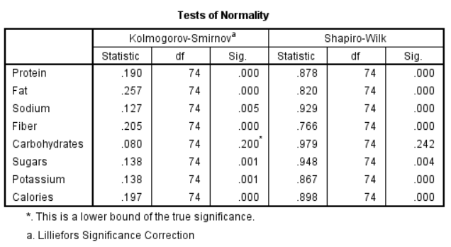

Since both the Kolmogorov-Smirnov test and the Shapiro-Wilk test gave out a p-value (sig) of less than 0.05 for all the variables except for the carbohydrates the hypothesis that these follow a normal distribution has to be rejected. These are not normally distributed and thus

one can conclude that only the carbohydrates is normally distributed since it is greater than 0.05.

Due to the lack of normality the Non-Parametric Spearman correlation test is to be carried out.

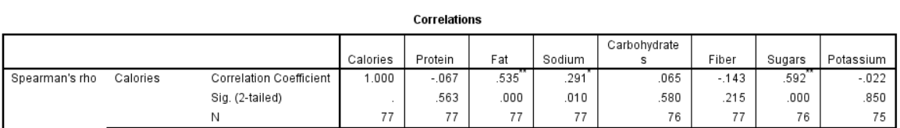

From the resulting output, Spearman coefficient is 0.891 and the resulting pvalue is 0.001 which is less than 0.05 meaning that the resulting correlation is significant. So there is a monotonic relationship between the rankings given by the two interviewers. As you can see the conclusion here is different from that made when looking at the Kendal tau correlation coefficient but this is not surprising since one is measuring agreement and the other is measuring the presence of a monotonic relationship. A monotonic relationship can exist even when there is no agreement.

**5 Modelling**

**6 Conclusion**

* <https://statistics.laerd.com/spss-tutorials/mann-whitney-u-test-using-spss-statistics-2.php>